**CHAPTER ONE**

**INTRODUCTION**

# 1.1 BACKGROUND OF THE STUDY

Nowadays, advertising is seen as a vital part of business marketing. Sellers are engaging in various kinds of approaches to advertise their stores or products as more and more advertising models are available (e.g., Web advertising, Social Media advertising, In-app advertising). In the context of increasing competition, it is getting harder for shop owners to increase their markets and popularize their products. In many cases, shops do not get enough customer engagement even though they spend a lot of money and resources. Since every business wants to grow and develop a strong client base. Advertising or promoting a business is key to achieving this growth. Advertising methods include traditional marketing methods as well as newer, modern methods. The devices most often used for IT services are changing from PCs and laptops to smart phones and tablets. These devices need to be small for increased portability. Location-based mobile advertising (LBA) is a new form of advertising that integrates mobile advertising with location-based services. The technology is used to pinpoint a consumer location and provide a location-specific advertisement on their mobile devices. Location Based Advertising (LBA) has been around for years. With the rise of regional and local newspapers in the 19th century there was an influx of advertising which was tailored to your local area. These adverts were relevant, split by sector and some even offered vouchers and coupons which could be cut out to be claimed. Although static they bear a lot of resemblance to what is happening in this space today. We are all part of a technological revolution; smart phone technology is rapidly growing and the rate of consumer adoption is matching it. It is technology that has driven the capabilities of Location Based Advertising and has opened the door for marketers to use clever techniques to get their brand in front of consumers. Mobile devices are very personal to the user. It is therefore very important that, with any location-based marketing technique, the privacy of the user is safeguarded at all times. In most cases, the consent of the user will be required and it will be important to determine where this is sought as it may vary between business models. In any case, it is vital that marketers offer users transparency about the location data that is collected and used and ways to control it.

# 1.2 PROBLEM STATEMENT

Advertisements are public notices designed to inform and motivate about Paid, non -personal, public communication about causes, goods and services, ideas, organizations, people, and places, through means such as direct mail, telephone, print, radio, television, and internet. There was not any direct way of publishing advertisement to user. They have to use some medium for advertisement. Location Based Advertisement will help people to get the required advertisement easily based on their locality

A large amount of sellers include many small business owners acknowledge that they should advertise their shops and the products to attract more consumers. However, they may find current advertising models do not suit their shops after the trial. The reasons may cause the failure are as follow:

* Huge cost in Advertising: advertising usually accounts for a big portion of marketing fee and sometimes it may also bring some other kinds of expenses or even waste. Some traditional advertisement tool such as flyer and poster will consume the resources of wood and may lead to some pollution. For example, some people may throw these papers away quickly without throwing them into the rubbish bin.
* Need long time to acquire advertising revenue It is hard to see the profit which is brought by advertising quickly. Usually it will take a long time to see if the published advertisement can acquire revenue. This is because the release and the spread both need a period of time. To be precise, consumers need time to browse and accept the content of advertisement and then it may be possible for them to arise the purchase intention. At the same time, statistics and comparison of sales also require some time.
* Unexpected imbalance between cost and income of advertising Lots of advertisements cannot reach the prospective objective which means that the advertisers may not gain enough money to defray the expense of advertising. Unexpected imbalance is usually caused by wrong strategy or analysis, it also may result from the incorrect and inappropriate advertising approaches and objectives.

**1.3    AIMS AND OBJECTIVES OF THE STUDY**

In order to mitigate the above problems and to provide owners of small businesses with support on advertising, this project aims to implement and apply a real-time and location-based advertising model in a system called NATURAL HAIR. This advertising model applied will enable sellers to publish advertisements (information) within a specific area and then this information is automatically displayed to active target users immediately they visit the web-page. This project first investigates the traditional or existing advertising methods and how the new advertising model (location-based advertisement) may bring benefits to small businesses, based on the platform of web application.

* To help small businesses (hair stylist in particular) to improve advertising effectiveness.
* Advertisements will get to targeted audience with location based and real-time.
* Reduce cost of advertising and control any waste that the traditional system of advertising might incur.

Natural hair is a real-time and location-based information retrieving and publishing system. It consists of two separate modules. One of them is oriented to common users and it could be used to search available hairstylist in a certain location immediately. Besides these, the system also supplies advertisements based on user’s location upon the visit to the web page without search which means it uses the GPS (Global Positioning System) of user’s device to track their location. Another application is oriented to Admin (especially for the owners of the hairstylist businesses). This application allows admins to manage and update real-time product information and publish their advertisements (or any other promotion information, coupon, etc.) based on location. In summary, the objective of this project is to help hair stylist to improve their advertising effectiveness and save the money through a new real-time and location based advertising model, also this proposed system will give admins the privilege to use their handheld device to release information within specific range, after which these information will be posted on the platform to be displayed to those visiting (users) the website.

**1.4    LIMITATIONS OF THE STUDY**

Location-based mobile targeting improved in accuracy with the geofence. However, on a precision basis, it’s still not perfect. GPS has issues in some indoor spaces. it might be incredibly effective at understanding where a person is in their car whilst driving. As soon as they enter an indoor space, GPS can be temperamental. Some may argue that this level of detail is neither here nor there. But the problem arises when location data providers can’t differentiate between accurate data and inaccurate data. Advertisers and marketers don’t know when the data fueling their campaigns is incorrect.

# 1.5 SIGNIFICANCE OF THE STUDY

The proposed system is able to provide vendors a convenient way for editing and publishing advertisement at low cost and effective way to implement digital advertisement publishing mechanisms. The location-based advertising is very effective as visitor’s location is tracked upon visit to the web page and links to the database to fetch advert matching the location. The proposed systems provide Real-time advertisement to user, which is Convenient as the content is kept down to a minimum.

With the use of geo-analytics and location-based campaign reports.

# CHAPTER TWO

## LITERATURE REVIEW

## 2.1 HISTORICAL BACKGROUND OF THE STUDY

Despite popular opinion, location-based advertising has been around for a while. Sure, it hasn’t always been backed by the smart technology in your mobile phone. Buy it has existed in some form. Local marketing strategies have been a key part of marketing since the practice began. It might not have been as effective, but brands have been trying to target users based on location since well before most of you reading this were born. Advertising space has always been purchased based on its location. Be it a metro station in an affluent Paris Arrondissement. Or a teenager holding a sign advertising bagel in a certain street.



Figure 1 A teenager holding Advertising bagel in the street

Location-based marketing has developed a lot since then. The underlying technology has advanced at an alarming rate. The ability to understand where audiences go and the ability to market to these is improved. Location-based marketing has always been around. But it did up its game in the 90’s once the internet found its way into most family homes. The dial-up broadband revolution had begun. Most families now had internet access in their home through (a large) desktop computer. For marketers, this meant that advertising could be delivered to a user based on their IP address. Thus, marketers could now target based on location, usually an area the size of a postal area. In the late 2000’s smartphones really took off. The first smart devices appeared and with the first iPhone, the race to create powerful mobile devices went mainstream. This led to rapid growth of mobile device adoption with GPS capability. This changed mobile targeting for good. It was now possible to use a device’s precise GPS satellite positioning to understand device location. This process is known as geofencing, geomarketing, or geotargeting. A geofence is a virtual boundary that is defined in order to perform a specific response once a device enters or leaves the defined area. More advanced geofencing is possible. An example is focusing on dwell time. Triggering a response when a device is within a geofence for a minimum amount of time. The geofence allows for mobile targeting to occur on an individual level anywhere. It means that audience segmentation can occur based on individual movement. But it did more than previously possible. It was now far more accurate. This meant that personalization (relevant to location) was now available. Location-based marketing was now personal and precise.

### 2.2 TRADITIONAL ADVERTISING

The traditional advertising is still a general model for advertising. Almost everyone could usually see various advertisements belong to this kind of advertising model in daily life. traditional advertising is “messages or commercials communicated through historically established media such as television, radio, outdoor (billboards), print, and direct mail”. Standing from current advertising market’s point of view, traditional advertising usually represents advertising through television, radio, poster, flyer, magazine and some other media. The following paragraphs discuss and compare some different traditional advertising methods and the advantages or disadvantages of traditional advertising

* **Print advertising:** it mainly includes the advertising through billboards, newspapers, magazines or flyers. Billboard usually takes the largest forms and are very conspicuous. Most of the billboards are placed near the main roads and these advertisements must be short. Newspaper maybe one of the oldest advertising methods. In most cases, daily new edition “makes it also the most disposable type of advertising”. Compared with newspapers, magazines are more long-term. Additionally, magazines are more “typically passed off to others”, so the chance of the advertisements on magazine will be seen is higher. Flyers, also called leaflets, is a form of paper advertisement. They are inexpensive to produce. Author of described that “leaflet distribution is estimated at producing over £12, 000, 0000 worth of business in the UK each week.” That amount was only estimated through surveying large corporations. So, if take all businesses (include the small and medium corporations) that “use leaflet delivery campaigns as part of their marketing” in to account, the actual figure is likely to be much higher. This is a very huge number, but the “response rates from leaflet drops can vary enormously” and there are no guarantees of the business revenue.
* **Traditional broadcast advertising**: Traditional broadcast advertising refers to “commercials that air to the public on the radio or television.” It emerges with the growth of the availability of radios. Its goal is to leave an impression on people or “display and accentuate a lifestyle”. As television slowly “upstages radio”, advertising costs increase and the costs on the production of advertising also increase. In the meantime, the advertising messages are shaped in a much more robust, “image-heavy” form. This means that upfront expenses may be 11 high because advertisers need to hire professionals to “perform, light, shoot and edit” these advertisements, “on top of the cost of running it”. In terms of radio, it can reach a large area but the limit of it is that people may not hear the advertisement if they close the radio.
  + 1. **ADVANTAGES AND DISADVANTAGES OF TRADITIONAL ADVERTISING**

The traditional advertising model contains various advertising methods. It remains some advantages today. “It can be relatively effective for reaching a target audience and it can be affordable to advertise frequently”. People can touch, feel, hear and interact with this form of advertising. This kind of advertising also usually has a variety of styles, shapes, sizes, colors and so on. But traditional advertising is more expensive than newer advertising models. It does not allow advertisers to make responses to the changes in the marketplace as quickly as the newer forms of advertising. Besides, it usually takes a long time to publish due to the long period of print or production.

2.3. WEB ADVERTISING

Web advertising, sometimes also be thought of as the most common model of online advertising. Banner advertisements, AdWords advertisements, floating advertisements and some other website advertisements are all belong to this kind of advertising model. This advertising model appears after the boost of the use of Internet. “Web sales reached over 30 billion dollars in the year 2001”, the number is still increasing after a decade. Web advertising, the model used by sorts of interesting web applications (such as a lot of websites), is also be considered as one of the big surprises to the 21st century. It is even more useful than the subscription. The rest parts of this section aim to review and explain two typical advertising methods of web advertising and to summarize the merits and drawbacks of web advertising.

### 2.3.1 BANNER ADVERTISING

INVESTOPEDIA defines ‘banner advertising’ as “A rectangular graphic display that stretches across the top or bottom of a website or down the right or left sidebar.” Like picture-1, banner advertisements are usually image-based rather than text-based. These advertisements are also a very popular form of the website advertising

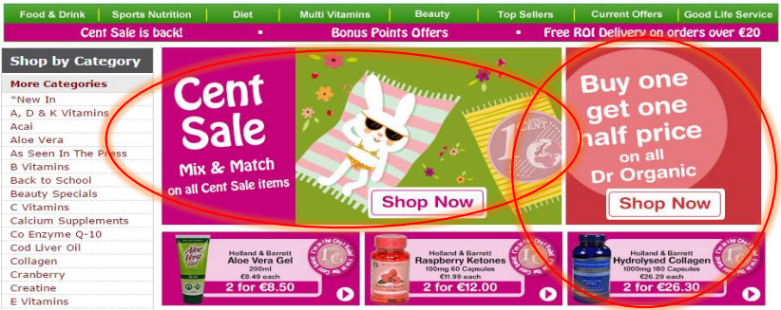

**Figure 2 Example of banner advertisement**

Banner advertising is generally used to promote an advertiser’s brand and/or to “get more visitors from the host website to go to the advertiser's website” or to the promotion page. This kind of advertising usually charge through three ways: cost per impression “(payment for every website visitor who sees the advertisement)”, cost per click “(payment for every website visitor who clicks on the ad and visits the advertiser's website)”, or cost per action (“payment for every website visitor who clicks on the advertisement, and then goes to the advertiser's website and completes a task” such as filling out a form or making a purchase directly). In fact, these three methods are the main ways to pricing the web advertising and they even are the usual methods for pricing most online advertising. Basic, the static banner advertisements are simple to produce but amateur banner advertisements often work fine and need the help of professional advertisement designers due to “ads competing for viewer attention”. As most forms of advertising, banner advertisements have considerable differences in quality because their creators’ abilities and experiences are different. The applicable scope of banner advertising is even greater than that of most other forms, and the banner advertisements are simple and inexpensive in many cases.

## ****2.3.2 ADWORDS ADVEETISEMENT****

“AdWords” is another very typical web advertising method. Google AdWords 2 is Google’s advertising system in which advertisers “bid on certain keywords in order for their clickable advertisements to appear in Google’s search results”. In most cases, the research in found Google AdWords is effective for various kinds of businesses on the condition that these advertisers do not waste their money on the inaccurate keywords or write “weak and low CTR (Click through rate) advertisements”.

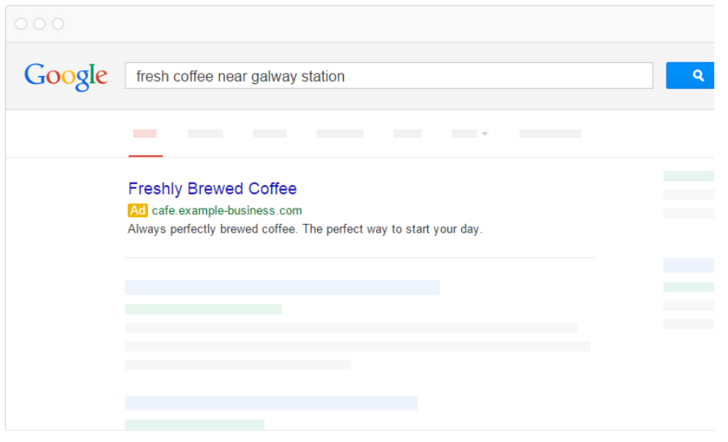  
figure 3 Example of AdWords advertisement on google

Advertisers that use the AdWords advertising need make payments based on CPC (cost per click), this means the payment an advertiser need to make depends on the amount of clicks that the company's advertisement receives. But if advertisers want their advertisement be placed in a good position on the search engine results page, they may need to pay more money to make sure their quality scores and the CPC is enough high. Sometimes, AdWords is a bit expensive, in this case, “most small businesses and startups are unable to compete with larger companies”. Some major companies such as L’Oréal and Estee Lauder already “locked down terms like moisturizer”, this means that small businesses or startups would “have to spend $5 or $7 per click for that term”. Moreover, there is a limit for the word number of AdWords advertisement and there is also the limit of advertisement display in the result page.

## ****2.3.3 SUMMARY OF WEB ADVERTISMENT****

Web advertising is almost a “necessity for modern businesses”, consumers increasingly rely on the Internet for more entertainment or information. The merits of web advertising mainly are the huge impacts of the Internet which enables advertisers can reach more people than traditional advertising methods at “a fraction of the cost”. Web advertising can also be more “targeted” than some “traditional advertising”, it enables advertisement messages can be seen by the most relevant consumers. At the same time, web advertising is real-time and usually can get real reflect from consumers. One obvious disadvantage of web advertising is that the “marketing materials are automatically available for others to copy, regardless of the legal ramifications”. Another disadvantage is that people may choose some filter tools to filter the web advertisements because there are massive advertisements on the web based on the rapid development of the Internet technology. In term of the expenses of web advertising, one company gives a sample pricing standard for web advertising (shown in Table 1).

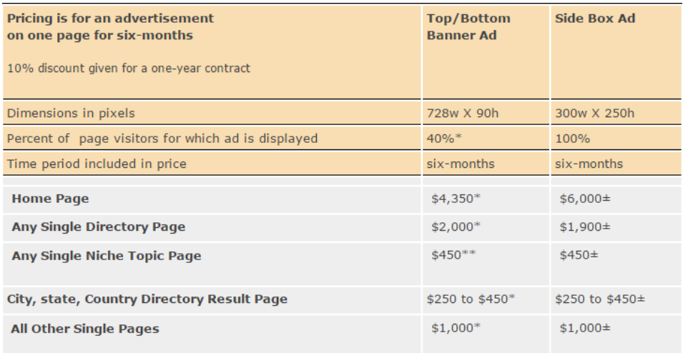Table 1 Sample of web advertising pricing

It also gives a sample for the specific position’s web advertising fee (shown in Table 2).

Table 2 Example of specific position’s advertising pricing

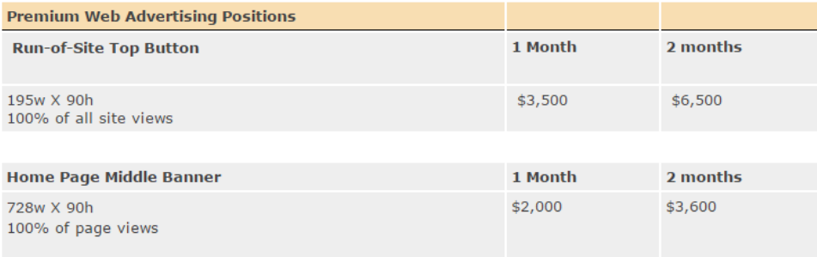

According to these two tables, it is not hard to find that web advertising is not very cheap and it may be harder for small businesses (such as small restaurants and small retail shops) to publish a lot of advertisements through this way.

### 2.4 ADVERTISING ON SOCIAL MEDIA

Unlike long time ago, people now prefer to use various newer communication tools to communicate with families and friends instead of traditional letter or even the telephone. Social media include “networks (e.g., Facebook, Twitter, and LinkedIn), wikis (e.g., Wikipedia), multimedia sharing sites (e.g., YouTube and Flickr), bookmarking sites (e.g., Del.icio.us and Digg), virtual worlds (e.g., Second Life), and rating sites (e.g. Yelp)”. The emergence of social media help people to break the geographic limits and enable them to share real-time feelings and experience. In the meantime, the wide use of social media brings new business opportunities to the advertisers. Social media advertising can be seen as a form of online advertising and it focuses on social networking service. This kind of advertising allows people to interact with each other and to share the product’s or brand’s information. According to some research, advertisers “spent $5.1 billion on social media advertising in 2013 and this figure is expected to exceed $14 billion by 2018”.

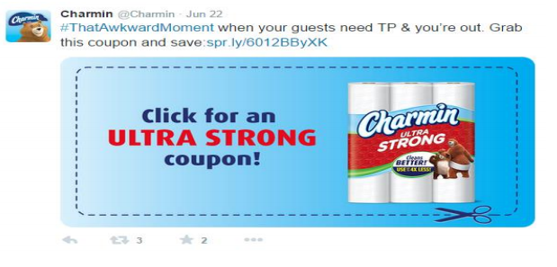Figure 4 Example of advertisement on Twitter

Taking Facebook as an instance, there are numerous categories of advertisements can be released on social media. The categories include: “Page Post Engagement (promote well-performing posts)”, Page likes (“get likes for the advertiser’s page and grow audience”), “clicks or links to website” (get people to visit advertiser’s website), “website conversions”, video views, “app installs(get consumers to install the mobile or desktop app)” and so on. Based on the research of social media advertising model, strengths of it can be basically summarized are as follow:

* This kind of advertising allows advertisers to “reach out to potential customers without spending exorbitant amounts of money” on advertising while keeping in touch with current customers.
* It allows advertisers to inform consumers or followers of “secret sales or special offers” quickly and simply. At the same time, consumers can contact the advertiser easily and this could enable sellers to respond quickly to any customers’ feedback.
* Social media advertising makes it possible for advertisers to indirectly post their links to website content by “appearing in universal search results”, this will contribute to improving the search traffic and online sales of them.
* Advertising on social media also provides an approach for advertisers to see the reflection of consumers and the reflection result could help them to improve the service in order to target more consumers.
* Most social networks are totally free for users to join and operate, while all advertisements could be viewed and transferred to any other people. Some “local businesses” may often “end up with followers who are not local”.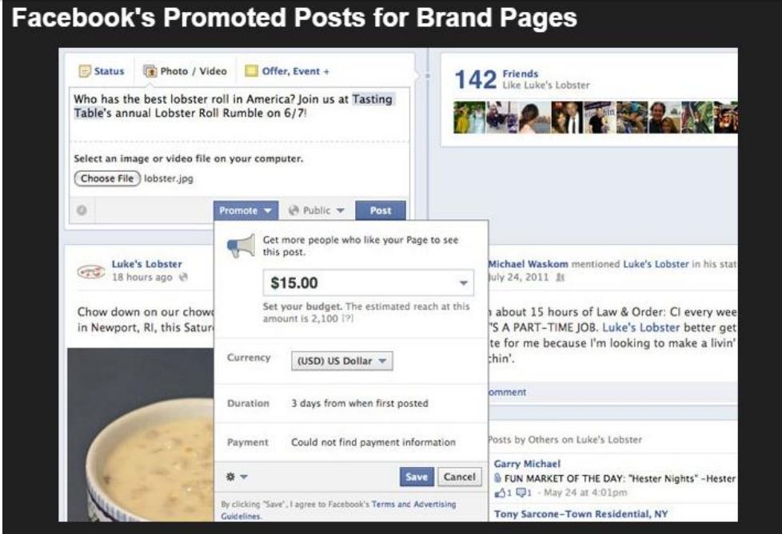

Figure 5 Facebook promoted post

With regard to the expense and effectiveness of advertising on social media, introduced some famous social media’s price for advertising and mentioned the effectiveness of this kind of advertising model. Pricing Some sources report that the average price for Facebook advertisement is around “25 cents for every 1,000 impressions while others point to it being over six or seven dollars.” In fact, advertisers can choose pay by CPC or CPM (explained in Appendix A), so in this case, seller need consider which model is more suitable for the shop. The cost of advertising on Twitter is determined by the type of advertisement. Promoting Tweets and accounts may cost the advertiser from “50 cents to 10 dollars or more per engagement (video view, link click, follow, etc.)” based on how targeted the advertisement is. As the payment method of Facebook, advertising on LinkedIn can also be paid on CPC (cost per click) or CPM (cost per thousand impressions), but LinkedIn sets a minimum budget of “$10/day for users of their ad platform”. There are also other pricing standards of LinkedIn such as “the minimum bids for CPC text ads ($2.00/click) and CPM text ads ($2.00/1,000 impressions)

**2.5 IN MOBILE APP ADVERTISEMENT (in-app advertisement)**

Following rapid growth and diffusion of the Smartphone, “the mobile advertising market now offers mobile applications as a unique new advertising medium with great potential”. Most in-app advertisements are operated by similar arrangements as traditional web advertisements. Developers enable the advertisements join in the network and then “sell off” advertising spaces in apps to advertisers. In-app advertisements may be published in different four sizes (shown in Figure 5) but all of them are smaller than traditional web advertisements due to the limited screen size. There are three common advertising approaches of in-app advertising:

* Fat Finger advertisements (also known as static ads), these advertisements are in-app banners advertisements that really depend on users “to inadvertently tap them” and themselves usually display as “static images or in video format”. Some of fat finger advertisements cannot be closed by users without download or even pay a little money.
* Card-based advertisements, this kind of advertisement has gone and “these advertisements natively blend into their app's interaction model”.
* Interstitial Advertisements, this kind of in-app advertising typically be used in mobile games. These advertisements usually command audiences’ full attention because they almost take up the entire screen in most cases. The most common way for mobile app advertising to cost advertisers’ money and “pay out to app developers” is CPC (cost per click), but there are also many other “commission structures available that pay for views, specific actions”, or simply pay the monthly rental fee for specific type and period. The price for in-app advertising varies in different advertising companies and the cost of advertising hence depends on the “model, region, operating system and targeting cut if any”. Main merit of in-app advertising is this kind of advertising is becoming a “reliable source of income at scale”.

There are also many drawbacks of in-app advertising. Firstly, advertisers must have a very large and active user base if they want to receive a “meaningful income”. Secondly, “on mobile tiny canvas, cluttering with advertisements detracts from the user experience and may diminish usage”. Additionally, massive advertisements in application are ignored by consumers, and this will gradually leave developers with “no interaction” and therefore, “no ROI (return on investment)”. Lastly, it is difficult both for advertisers and developers to “present advertisements of relevance and value” to suitable consumers at right time. According to a report by Juniper Research, “spending on in-app advertising is expected to reach $17 billion by 2018”. This mount considerably rises from the “$3.5 billion spent in 2013”, and makes “in-app advertising the fastest growing sector of the mobile advertising market”. In the field of mobile advertising, some experts think in-app advertising has great potential as an advertising model. Media Brix, an App ad company, found that “in-app ads can yield 20 percent engagement and 2,000% higher clickthrough.

2.7 LOCATION BASED ADVERTISEMNET

LBA (location based advertising) is not a complete advertising model, it is a strategy or it can also be considered as a new form of advertising as well as a part of LBS (location based service). LBA can integrate “mobile advertising” with “LBS”. [36] It can also be described as “a new form of marketing communication that uses location-tracking technology in mobile networks to target consumers with location-specific advertising on their mobile phones”. The opportunity for advertisers to utilize LBA increases tremendously in recent years. It plays a vital role in many sellers’ marketing campaigns and there are plenty of ways to use this method. Through a lot of successful examples of the practice of LBA, it has been proven to be an effective and successful strategy. There are two approaches of LBA: the “push” approach and the “pull” approach”. These two concepts are familiar in the context of “traditional marketing communications”, but they are defined differently with regard to “location based advertising”. Within the “push” method, advertisers may take some actions to push their advertisements to the user side and then consumers could choose to see it or quit. For example, the push approach may be used when users walk near a restaurant at lunch time and receive text messages from the restaurant which letting them know the menu of the lunch for this restaurant or a special meal today. But within the “pull” method, users are seeking the information they need rather than “the information seeking them”. For instance, a tourist wants to know where the nearest restaurant with cheap price is, so he is eager to find some related information in order to choose one restaurant from the seeking result. In other words, the pull approach means that “the user chooses the time and place to access the information”. The examples of the following two companies present the real practice of LBA and show the effectiveness of it.

2.7.1 LOCATION BASED ADVERTISEMNET FOR ADVERTISERS

Simply put Location Based Advertising allows brands to adapt their marketing message based on where consumers are geographically. By knowing where your consumers are, brands are able to tap into daily habits and also encourage consumers with relevant offers and messages which relate to their location. This can be very valuable - and as some of the case studies later in this paper show can actually increase the response, drive footfall into stores and influence spend. All very attractive for any marketer!

2.7.2 LOCATION BASED ADVERTISEMNET FOR CONSUMERS(USER’S)

With the rise of vouchers and as consumers become more tech savvy, consumers seem more than happy to receive information to their handset as long as it is relevant. According to a consumer survey carried out by the IAB in 2010, 49% of consumers would use LBA more if the information they received was more relevant and useful. Social media has played a big part in consumer adoption of LBA; if consumers are using the platform already, they are more receptive to use additional features like location. If they are getting something back and are able to connect with their friends, followers and circles this adds an even larger benefit.

**2.8 RELATED WORKS ON LOCATION-BASED ADVERTISEMENT**

O2’s Placecast O2, a famous phone operator, made “an interesting move and developed a service which is drawing invisible geo-tagged lines and borders” in certain areas. Then these will trigger “an SMS message to be sent to anyone” who are using the service when they “enter a new border”. Many big companies (such as Starbucks and L’Oréal) are on the board now because this service can help them to attract more customers, and of course, they certainly need the help from the service provider like O2. But it is hard to implement for some small shops because the price for this kind of service is usually high.

“Best Western mobile ad campaign generates 0.95 CTR” “Best Western” is relying on location-based advertising, which aims to target potential customers near airports or competitors’ locations. This company encourages customers to use their mobile devices to view the nearby hotels or directly book a room through the Internet. Through “leveraging location-based mobile advertising, hoteliers can capture these bookings by engaging travelers in proximity to their locations”. The highest daily CLR of the Best Western’s location-based mobile advertisement is “2.3 percent, which is significantly higher than the average network click-through rate of 0.8 percent”, according to data collected from PayPal Media Network.

There are a number of ways in which technology can be used to track a consumer’s location. Below are the three traditional methods which are currently available and commonly used for Location Based Advertising. Network-based This technique utilizes the service providers’ (mobile network operators MNOs) infrastructure to identify the location of a handset. This method is generally used by MNOs in a non-intrusive way without having to add any software to the handset. Examples of companies using this technique are O2 and Orange. Handset-based This technique requires the installation of software on the handset to determine its location. The location is found by computing the handset’s cell identification. In addition, if the handset is also equipped with Global Positioning System (GPS) then significantly more precise location information can then be sent from the handset. Hybrid This technique uses a combination of network-based and handset-based technologies to identify the location. One example would be some modes of Assisted GPS, which can both use GPS and network information to determine the location. Both types of data are used by the mobile phone to identify the location faster and more accurately.

**CHAPTER THREE**

**SYSTEM ANALYSIS AND DESIGN**

**3.1 INTRODUCTION**

Two-tier authentication (2FA) is an authentication method in which a computer user is granted Pankaj D Virulkar has given Location-based advertising (LBA) is a new form of advertising that integrates mobile advertising with location-based services. The technology is used to pinpoint consumer’s location and provide location specific advertisements on their mobile devices. According to Bruner and Kumar (2007), ”LBA refers to marketer-controlled information specially tailored for the place where users access an advertising medium” With the current rapid increasing use of smart phones, the mobile location based service market is growing to the point that location-based services are now a standard feature on many mobile devices. The greater availability of GPS phones, reduced prices, and app stores have all contributed to the rapid growth of location tools. Bernhard komel Advertisements or vouchers are commonly used today to attract the attention and the purchase of consumers by providing discount or detailed description to customers. Typically, vendors use text to describe characteristic introductions and images to express appealing looks. In order to allow consumers to retrieve more information such as location of vendors, an advertisement publishing system should be improved to meet the consumer’s requirements. Prem Kumar.B Advertisements or vouchers are commonly used today to attract the attention and the purchase of consumers by providing discount or detailed description to customers. Typically, vendors use text to describe characteristic introductions and images to express appealing looks. In order to allow consumers to retrieve more information such as location of vendors, an advertisement publishing system should be improved to meet the consumer’s requirements. This project proposes a location-based mobile advertisement publishing system, a framework for vendor editing, and location-based service. Most of the users keep their smartphones with them at all times, they visit websites or search engines for services they need, hence this project is centered at delivering optimum result of adverts using the visitor’s location.

**3.2 RESEARCH METHODOLOGY**

Generally, in the course of study, several methods can be used in order for successful data collection to be carried out, aimed for the project to be exposed to ease and flexibility in maintenance approach, those methods that were adopted are:

**3.2.1 DIRECT INTERVIEW**

This is a direct one on one communication process with an individual or organization involves so as acquiring data about the project of study. Direct interview and questionnaire are used to know the view of various individual on how location-based advert can make them get services rightly available in their location.

**3.2.2 ONLINE CONSULTATION**

In order to attain guidelines and study some related approaches in designing this system, there is consultation to the internet study sampled related reports and other ways in which advertisements are done and also gather historical information on location-based advertisement system.

**3.3 DESIGN METHODOLOGY**

While executing the design process, there exist tools preferences for the website development with reasons to justify why these tools are selected. Conclusion was made to use one of the scripting languages called PHP and Wamp testing server for MySql database development of the system and for testing the website on local host.

**3.4 DESIGN TOOLS**

**3.4.1 PHP:** It is an object-based scripting language used to design both a dynamic websites. The major reason behind the choice of PHP over all other scripting languages like asp.net, aspx.net etc. is that it requires lower resources to execute, it filters out memory that are not being used during utilization and of course it is highly secured and easy to learn.

**3.4.2 MySQL:** It is an open-source relational database management system. It is a freely available open source Relational Database Management System (RDBMS) that uses Structured Query Language (SQL). SQL is the most popular language for adding, accessing and managing content in a database. It is most noted for its quick processing, proven reliability, ease and flexibility of use. There are several choices of databases but the one being chosen as a database choice is MySql due to the luxurious acquisition of data, its flexibility in querying of database, and its nonselective connection to all computer object oriented scripting and programming languages (it is compatible with any object oriented language).

**3.4.3 LARAVEL:** It is a free open-source PHP web framework, created by Taylor Otwell and intended for the development of web applications following the model-view-controller (MVC) architectural pattern and based on Symphony. Some of the features of Laravel are a modular packaging system with a dedicated dependency manager, different ways for accessing relational databases, utilities that aid in application deployment and maintenance, and its orientation.

**3.5 AUTHENTICATION SYSTEM ARCHITECTURE**

The Main components of this architecture are Geolocation Api, Database, Webpage, Web browser and Mobile Devices. The user can receive advertisements from the server. Advertisements will get displayed based on location of user. Whenever the user visits the webpage, the advertisements will be pulled from the server and will be displayed on the landing page(homepage).



Admin

Location-Based Advert System

Database

Geolocation API



Mobile phone with browser



Visitors (user’s)

**Figure 6: LBA SYSTEM ARCHITECTURE**

**3.7 DATABASE DESCRIPTION**

The website interface communicates with a database named “location-based-advert” which consists of three major database tables, a database populating tables for storing backend registered user’s personal details and login information. Each table work with the other in order for the application to work effectively. These database tables are: register, advert and history database and its tables each is also being tabulated with their various properties in figure 7.

Location-based-advert (database)

register (table)

advert (table)

History (table)

**Figure 7**: **Database Description**

**3.7.1 Register Table**

The register table stores the data of all the user of the system, it has ID which is auto-increment and a field called active which set the value of the user.

**Table 3: Register Table**

|  |  |
| --- | --- |
| Id | INT (Auto increment) |
| Company name | VARCHAR |
| Company email | VARCHAR |
| password | VARCHAR |
| address | VARCHAR |
| state | VARCHAR |
| town | VARCHAR |
| lga | VARCHAR |
| zip | VARCHAR |
| contact | VARCHAR |
| Alternative contact | VARCHAR |
| image | VARCHAR |
| activate | VARCHAR |
| token | VARCHAR |
| status | VARCHAR |
| Date | TIMESTAMP |

**3.7.2 Advert Table**

Advert table stores the details of all the advertisement posted by the admin; it saves the company name, company address, advertisement, pictures for advert, location(city), state, contact number. It is the main table where advertisement are being pulled.

**Table 4: Advert Table**

|  |  |
| --- | --- |
| Id | INT (Auto increment) |
| Company name | VARCHAR |
| Company address | VARCHAR |
| city | VARCHAR |
| state | VARCHAR |
| token | VARCHAR |
| Advert | VARCHAR |
| Phone | VARCHAR |
| Image | VARCHAR |
| time | TIMESTAMP |

Top tips

Use a location based ad creative. Always state the location of the user in the creative. This can be the actual place name or just the environment. If someone is at the train station or airport then a message referring to the wait for departure will attract many more clicks than a generic brand message.

Try to use mobile maps in your creative. Whenever people use their mobile to view media there is a good chance they are out and about. Showing someone where they can interact with your brand on a mobile map can increase engagement over regular banner ads.

Use sensible geo-fencing. Whilst it may sound ideal to only target consumers walking past your store the reality is that only a few percent of your audience will be doing that when your ads go live. Try blending store targeting with a more general lifestyle geo-fence like retail spots to get higher campaign delivery.

Make use of your geo-analytics and location based campaign reports. Whilst location based advertising can be a little more expensive than regular banner ads the learnings can be invaluable. Make sure you are clear which locations performed best and why. Then pass this data onto the rest of the marketing team. For example knowing why a certain store got more footfall on a Friday may help shape the Outdoor or TV advertising schedules.

Look out for new KPIs. Although CTR and CPC may be your key metrics for online advertising it doesn't guarantee the same results on mobile. Mobile is a different medium and so your brand may find different ways of measuring success. Certain high street retailers will realise that a 60 second expandable map interaction is more powerful than a 10% CTR as zooming in and out of the map show the start of consumers’ journeys to a store.